**Experiment - 1**

**WEEK - 8**

AIM ::

Write a Python program that copies a file from one directory to another using the shutil module.

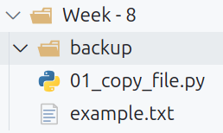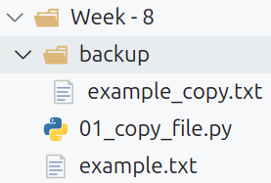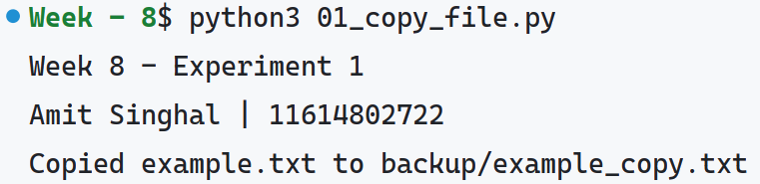

**Experiment - 2**

AIM ::

Write a Python script that compresses multiple files into a .zip archive using the zipfile module.

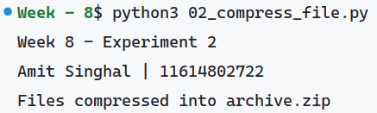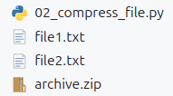

**Experiment - 3**

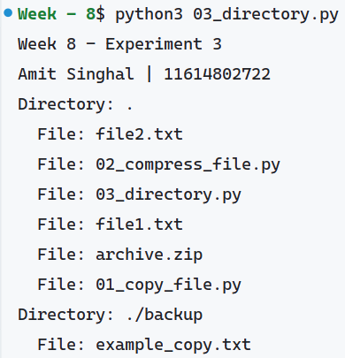

AIM ::

Write a program to display the directory structure using os.walk().

**Experiment - 4**

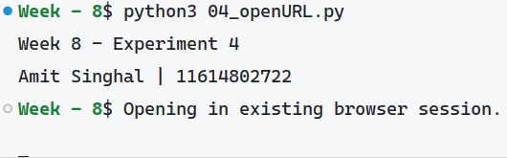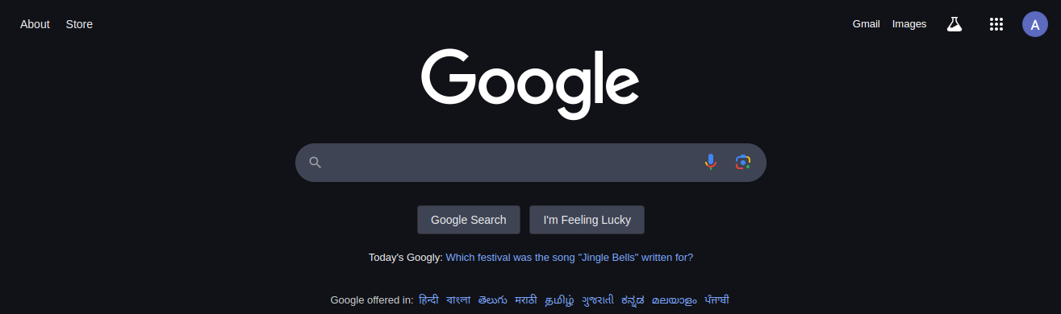

AIM ::

Use the webbrowser module to open a specific webpage in the default web browser.

**Experiment - 5**

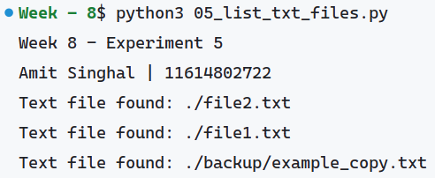

AIM ::

Walk through a directory and list all .txt files using os.walk().

**Experiment - 6**

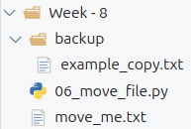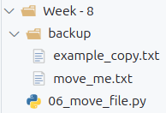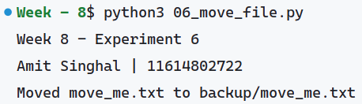

AIM ::

Write a Python program that moves files from one folder to another using shutil.move().

**Experiment - 7**

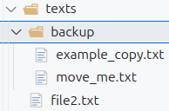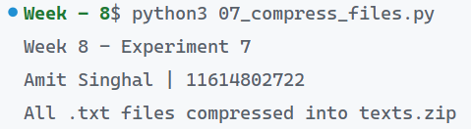

AIM ::

Compress all .txt files in a directory into one .zip archive using the zipfile module.

**Experiment - 8**

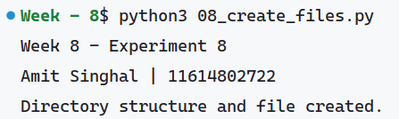

AIM ::

Write a Python program that creates a directory structure and writes a few files into the directories using os and shutil.

**Experiment - 9**

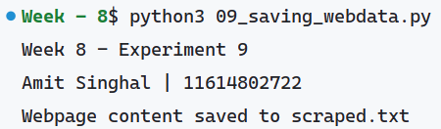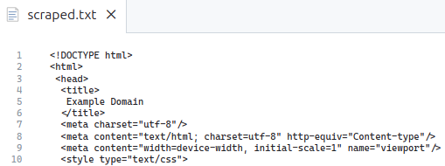

AIM ::

Use requests and BeautifulSoup to scrape data from a webpage and save the content to a file.

**Experiment - 10**

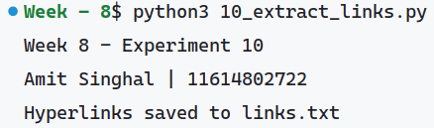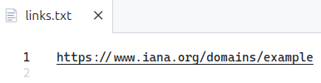

AIM ::

Write a Python script to extract all hyperlinks from a webpage and save them to a text file.

**Experiment - 11**

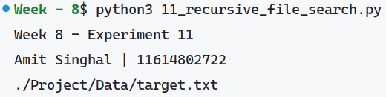

AIM ::

Write a program to recursively search for a file in a directory and all its subdirectories using recursion.

**Experiment - 12**

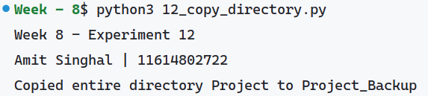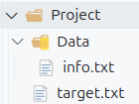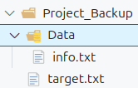

AIM ::

Write a Python program to copy an entire directory along with its files to another location using shutil.

**Experiment - 13**

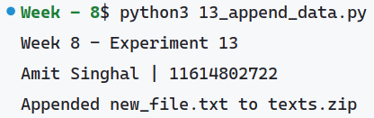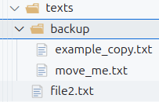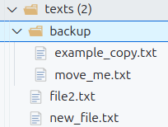

AIM ::

Write a Python script to append new files to an existing .zip archive using the zipfile module.

**Experiment - 14**

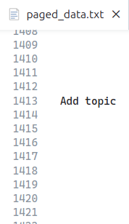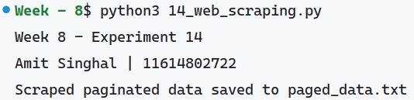

AIM ::

Write a program to scrape data from a website with multiple pages and save all the scraped data to a file.

**Experiment - 15**

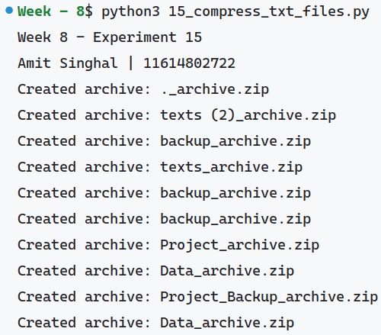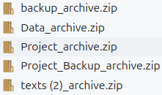

AIM ::

Write a Python program to compress all .txt files from multiple directories into separate .zip archives.